**ROCK PAPER SCISSORS-GAME**

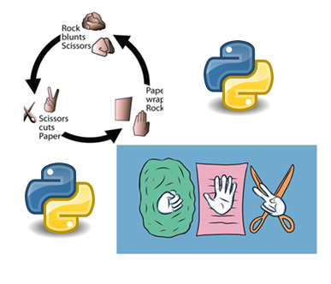

**MADE BY-**

**VEDANT ARORA**

**XII-C**

**Roll no.:**



**CERTIFICATE**

This is to certify that Vedant Arora of class XII-C has completed the project “Rock, Paper, Scissors- Game” during the session 2020-21 under my guidance and supervision.

**Mrs. Kamaljeet Kaur**

**Computer Science Teacher**

**ACKNOWLEDGEMENT**

I would like to express my special thanks of gratitude to my teacher Ms. Kamaljeet Kaur who gave me the golden opportunity to do this wonderful project, which also helped me in discovering and learning new things.

Secondly I would also like to thank my parents and friends who helped me with this project who helped in making and finalizing the project within the given time frame.

# Contents

### Introduction of the Project

1. System Requirements of the Project
2. Modules and methods used
3. Files and tables used
4. Python Coding
5. Output of the Project
6. Bibliography

**Introduction of the Project**

We, Vedant Arora & Raunaq Singh the students of **CLASS XII C of Fr. Agnel School, New Delhi** have been assigned the work of **Rock, Paper, Scissors- Game.**

**The project contains –**

1. Main menu
2. The game- i.e., rock, paper, scissors
3. Leaderboard- To maintain the scores of the players
4. And an exit option

Ms. Kamaljeet Kaur, our subject teacher has also helped us a lot to complete this project. We feel so blessed that we have learnt all this work with the help of our teacher, and providing us various facilities to complete this project.

As we are the students of **CLASS XII C** and we haven’t done this type of project before, we have performed all that which we have learnt from our Computer Science Programming syllabus.

**System Requirements of the Project**

**Recommended System Requirements**

Processors: Intel® Core™ i5 processor

Disk space: 2 to 4 GB.

Operating systems: Windows® 10, MACOS, and UBUNTU. Python Versions: 3.X.X or Higher.

Spreadsheet software: MS Excel

**Minimum System Requirements**

Processors: Intel® Core™ i3 processor or Intel® Core™ i5

Disk space: 1 GB.

Operating systems: Windows 7 or later, MACOS, and UBUNTU. Python Versions: 2.7.X, 3.6.X.

Spreadsheet software: MS Excel

**Note:-**

**Python must be installed on your machine.**

**Modules & Methods used**

**Random module in Python**

The **random module** is a built-in **module** to generate the pseudo-**random** variables. It can be used perform some action **randomly** such as to get a **random** number, selecting a **random** elements from a list, shuffle elements **randomly**, etc.

We used it to generate random outputs of rock, paper & scissors.

**CSV module in Python**

The so-called **CSV (Comma Separated Values)** format is the most common import and export format for spreadsheets and databases. The CSV module implements classes to read and write tabular data in CSV format.

We used it to store and format the data of the leaderboard i.e., name of the player and the score.

**sys module in Python**

The **sys module** in Python provides various functions and variables that are used to manipulate different parts of the Python runtime environment. It allows operating on the interpreter as it provides access to the variables and functions that interact strongly with the interpreter.

We used it to create an exit portal option for our game.

**CSV FILES**

All the scores along with player names are stored in an MS excel sheet which has been created using CSV files named as **Leaderboard.csv**

**SOURCE CODE**

import csv

import sys

import random

print("*"*20,"FR. AGNEL SCHOOL, NEW DELHI ","*"*20)

print("*"*20,"Rock, Paper, Scissors- Game ","*"*20)

def get_user_ID():

try:

with open("leaderboard.csv" , "r" , newline = "") as file:

try:

reader = csv.reader(file)

length = 0

for row in reader:

length += 1

except EOFError:

length = 0

return str(1 + length)

except FileNotFoundError:

f = open("leaderboard.csv" , "w" , newline = "")

f.close()

return 1

def check_user_id(id):

try:

with open("leaderboard.csv" , "r" , newline = "") as file:

reader = csv.reader(file)

for row in reader:

if row[0] == id:

return True

return False

except FileNotFoundError:

f = open("leaderboard.csv" , "w" , newline = "")

f.close()

return False

def new_user():

print ("Please enter your name")

name = input().title()

if name:

print (f"Please remember that your user ID is {get_user_ID()}")

with open("leaderboard.csv" , "a" , newline = "") as file:

lst = [get_user_ID() , name , 0]

writer = csv.writer(file)

writer.writerow(lst)

else:

print ("Please enter a valid name from next time")

def update_record(id , score):

with open("leaderboard.csv" , "r" , newline = "") as file:

reader = csv.reader(file)

lst = []

for row in reader:

lst.append(row)

for record in lst:

if record[0] == id:

record[2] = str(int(record[2]) + score)

with open("leaderboard.csv" , "w" , newline = "") as file:

writer = csv.writer(file)

writer.writerows(lst)

def display_records():

try:

with open("leaderboard.csv" , "r" , newline = "") as file:

reader = csv.reader(file)

lst = []

for row in reader:

lst.append(row)

if lst:

print ("ID \t\t\t NAME \t\t\t SCORE")

for record in lst:

for data in record:

print (data , end = "\t\t\t")

print ()

except FileNotFoundError:

f = open("leaderboard.csv" , "w" , newline = "")

f.close()

print ("NO RECORDS EXIST")

def display_particular_record(id):

try:

with open("leaderboard.csv" , "r" , newline = "") as file:

reader = csv.reader(file)

for row in reader:

if row[0] == id:

print ("ID \t\t\t NAME \t\t\t\t SCORE")

print (f"{row[0]} \t\t\t {row[1]} \t\t\t {row[2]}")

return

print ("PLEASE ENTER A VALID USER ID")

except FileNotFoundError:

f = open("leaderboard.csv" , "w" , newline = "")

f.close()

print ("NO RECORDS EXIST")

def game_round():

score = 0

print ("Winning Rules of the Rock paper scissor game as follows")

print ("Rock vs Paper->Paper wins")

print ("Rock vs Scissors->Rock wins")

print ("Paper vs Scissors->Scissors wins")

print ()

print ("Here are your choice")

print ("1. Rock")

print ("2. Paper")

print ("3. Scissors")

print ("Please enter your choice")

choice = int(input())

while choice < 1 and choice > 4 and choice:

try:

choice = int(input())

except ValueError:

print ("Please enter a valid choice")

if choice==1:

print("Your choice=Rock")

if choice==2:

print("Your Choice=Paper")

if choice==3:

print("Your Choice=Scissors")

comp = random.randint(1,3)

if comp==1:

print("computer=Rock")

if comp==2:

print("computer=Paper")

if comp==3:

print("computer=Scissors")

if choice == comp:

return 0

elif choice == 1 and comp == 3:

return 2

elif choice == 2 and comp == 1:

return 2

elif choice == 3 and comp == 2:

return 2

else:

return -1

def main_game():

ID = input("Please enter the user ID ").rstrip()

valid = check_user_id(ID)

while valid:

print ("Do you want to play ? (Y/N) ")

choice = input()

if choice.lower() == "n":

break

elif choice.lower() != "y":

print ("Please enter a valid choice")

continue

else:

score = 5 * game_round()

update_record(ID , score)

if score > 0:

print ("You won the round")

elif score == 0:

print ("Round tied")

elif score < 0:

print ("You lost the round")

if not(valid):

print ("Please enter a valid user ID")

def main_menu():

while True:

print ("1. Add a new Record")

print ("2. Display particular record")

print ("3. Display all the records")

print ("4. Play a game")

print ("5. Quit")

print ()

choice = int(input("Please enter your choice(1/2/3/4/5) "))

if choice == 1:

new_user()

elif choice == 2:

id = input("Please enter the ID of the person you want to show record for")

if check_user_id(id):

display_particular_record(id)

else:

print ("NO RECORDS EXIST !!!!!")

elif choice == 3:

display_records()

elif choice == 4:

main_game()

elif choice == 5:

break

else:

print ("Please enter a valid choice")

print ('\n\n')

main_menu()

# Output of the Project

**Finally, we conclude our work and present the output of the Project.**

## MAIN SCREEN

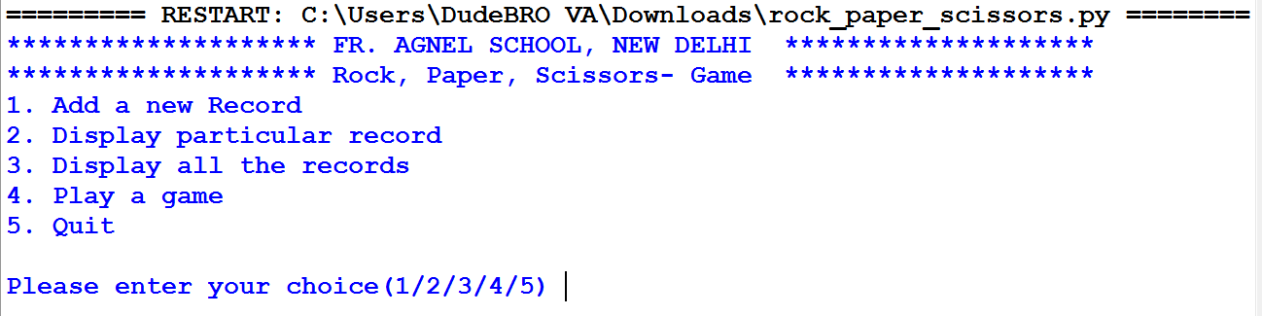

**ADD A NEW RECORD AND GET A PLAYER ID**

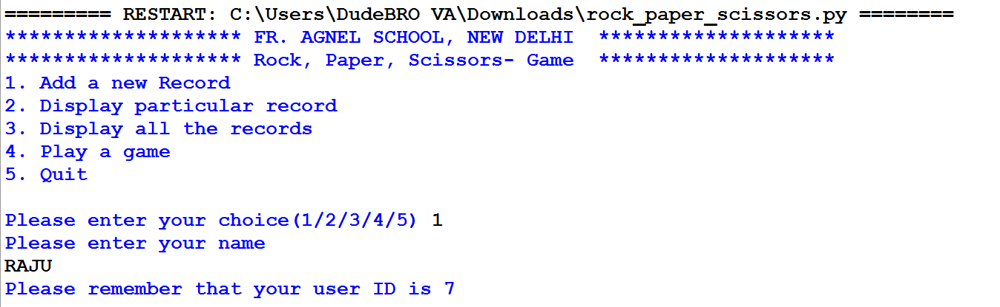

**DISPLAY A PARTICULAR RECORD**

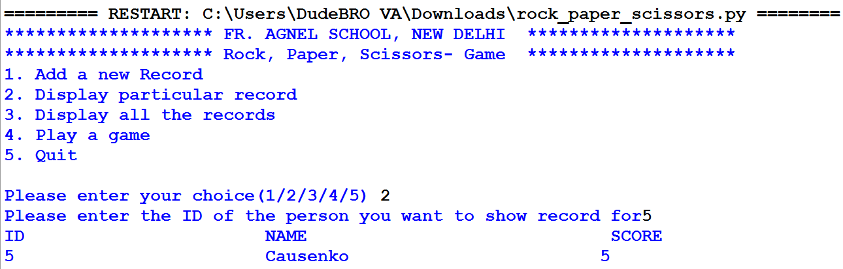

**PLAY A GAME**

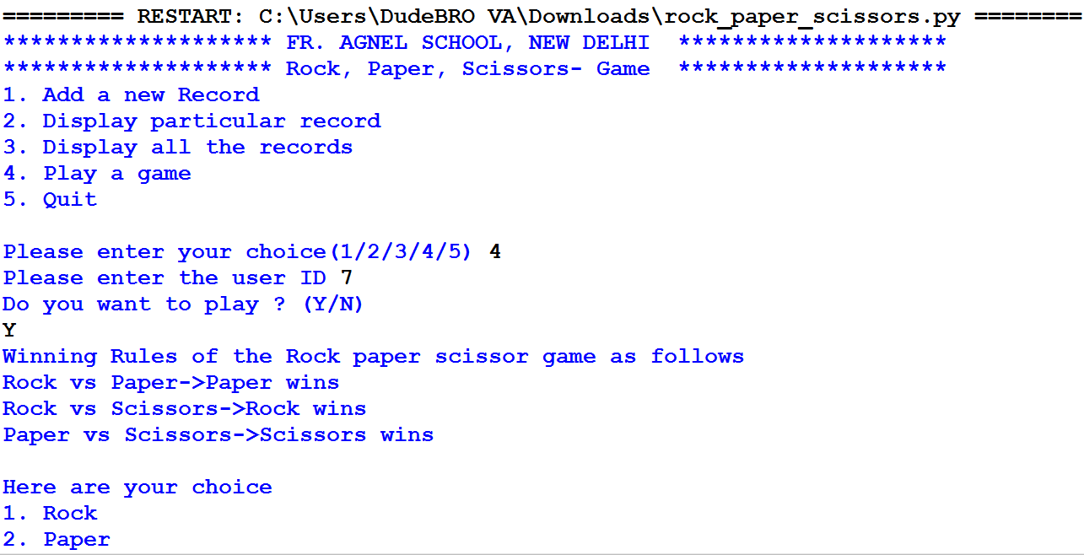

**CHOOSE ROCK, PAPER, SCISSORS**



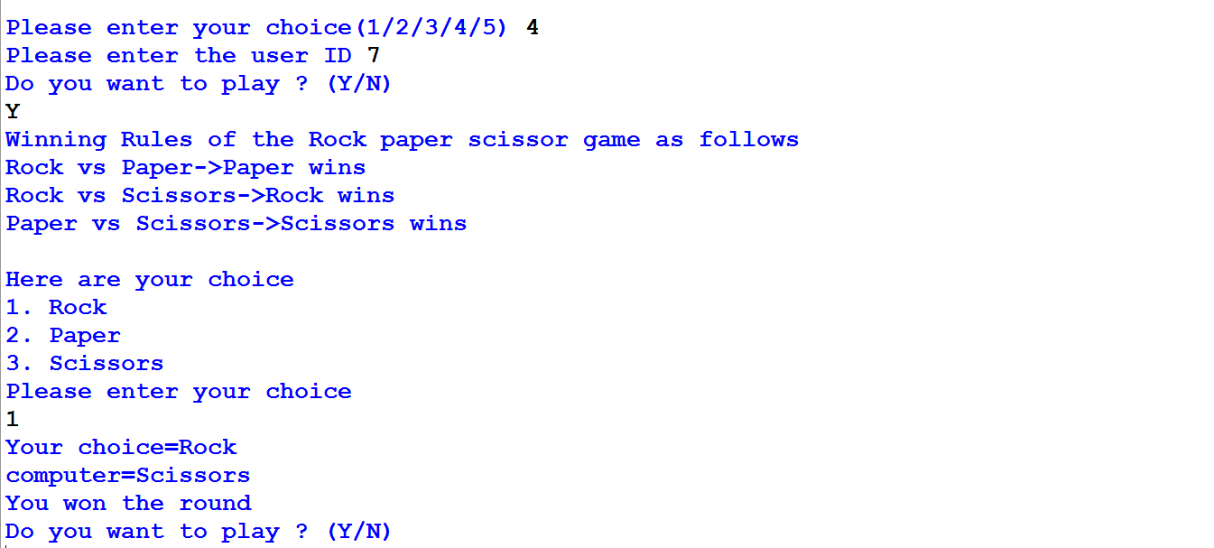

**CASE1- USER WINS**





**CASE 2- TIE**

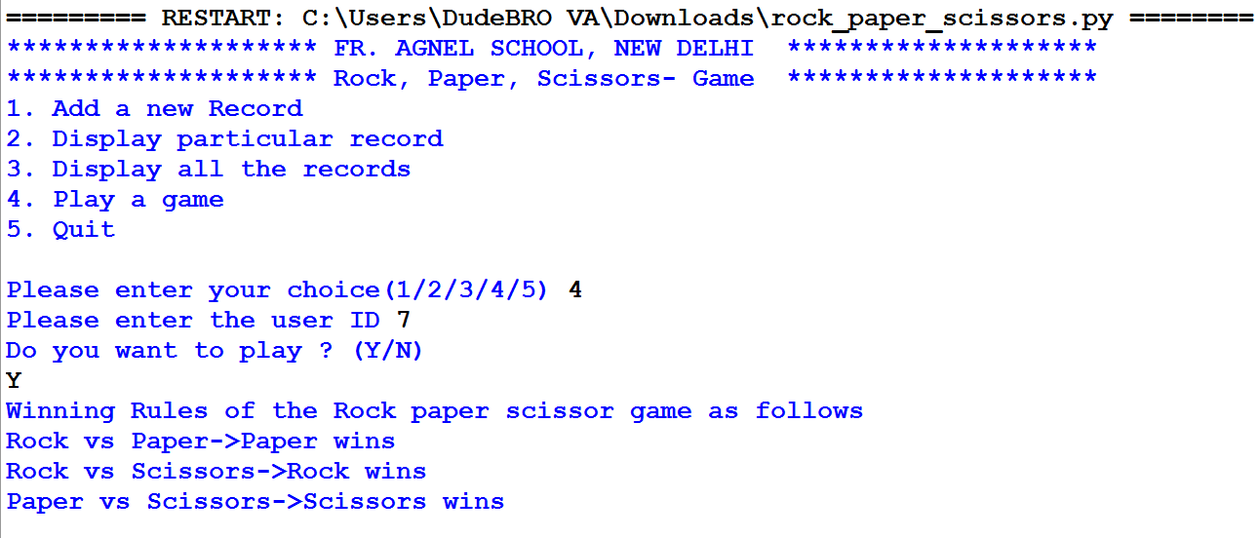

**CASE-3 COMPUTER WINS**

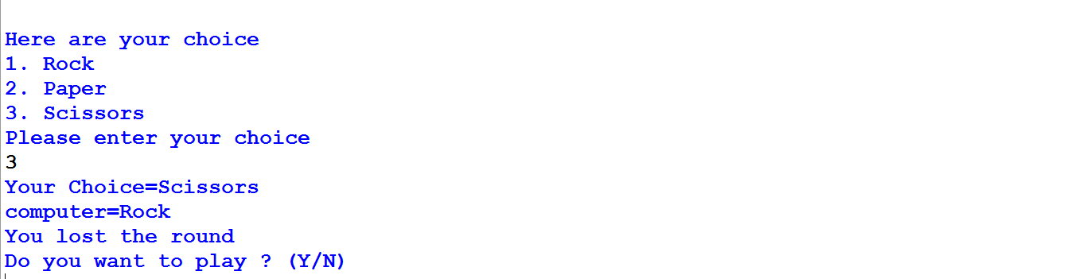

**LEADERBOARD**

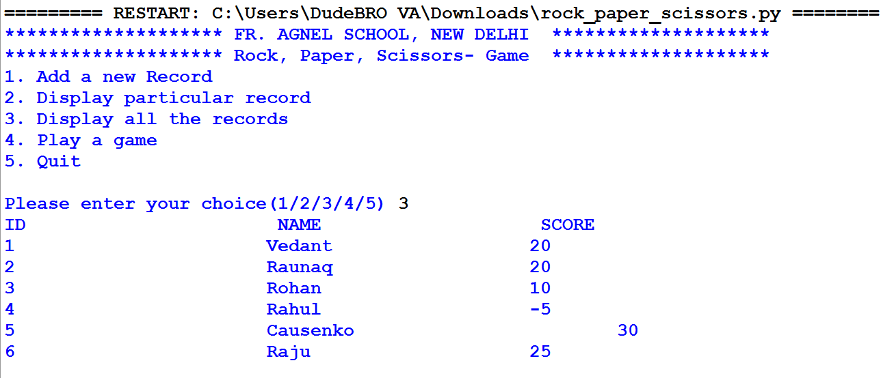

**LEADERBOARD IN MS EXCEL**

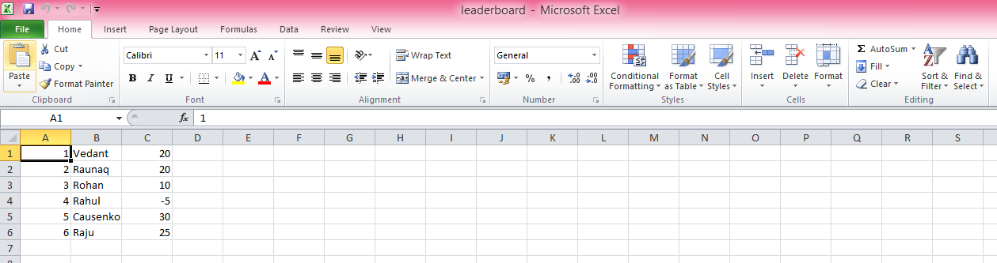

**.**

**Bibliography**

1. <https://www.google.com/>
2. <https://www.geeksforgeeks.org/python-sys-module/>
3. <https://docs.python.org/3/library/csv.html>
4. Textbook for CBSE class XI & XII- Computer Science with Python- Preeti Arora